Doctor
First Name
Last Name
Gender
Upton
M
Jeanette
Austin
F
Steven
Owen
M
Colorado
Reuben
M
Levi
Thaddeus
M
Knox
Grady
F
Ori
Yuli
M
Chava
Gannon
F
Geraldine
Walker
F
Hayfa
Baxter
M
Talon
10
Number of Accounts In This Category:
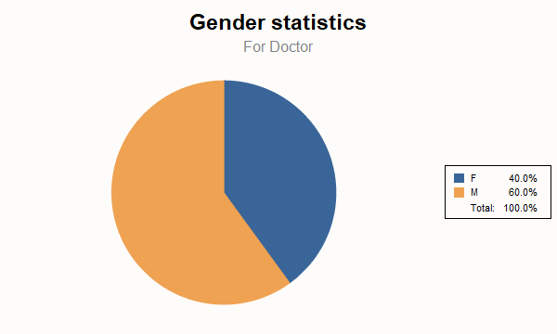

Patient
First Name
Last Name
Gender
Barry
M
Tanya
Flynn
F
Lysandra
Barry
M
Tanya
Flynn
F
Lysandra
4
Number of Accounts in This Category:
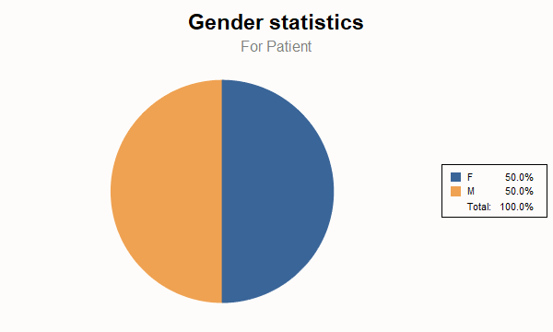

Pharmacist
First Name
Last Name
Gender
Demetrius
F
Sydney
Francis
F
Derek
Kenneth
M
Ali
Brennan
F
Julie
Barry
M
Tanya
Flynn
F
Lysandra
Oliver
F
Chantale
Orlando
M
Ferris
Felix
F
Medge
Levi
F
Georgia
10
Number of Accounts in This Category:
